Hawthorn FC Web App Screens 8/4/2026
1. Authentication & Access Control
- Title: Secure Login Terminal (Google OAuth)
- Function: Provides the primary security gateway, authenticating users against Hawthorn’s authorized personnel list.
- Features: Single Sign-On (SSO) via Google, role-based session initialization (Coach vs. Player), error-handling for unauthorized non-squad emails, and a premium "The Nest" dark-themed branded interface.
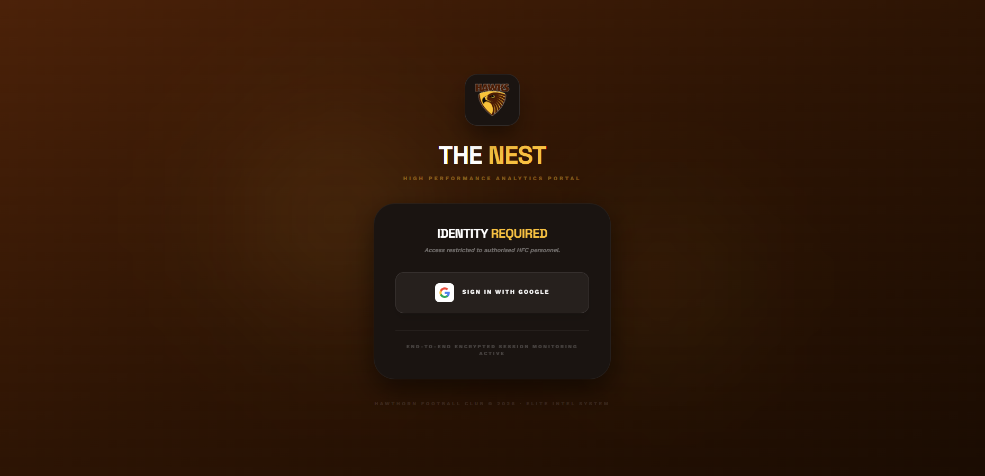

2. Strategic Dashboard
- Title: Coach Dashboard
- Function: Aggregates high-value team metrics and daily operational schedules for coaching staff.
- Features: Team Insights KPI cards, Daily Schedule timeline, Wellbeing aggregators (Sleep/Mood/Stress), daily insights on wellbeing and performance as well as live attendance indicators.
- Access: Coaches
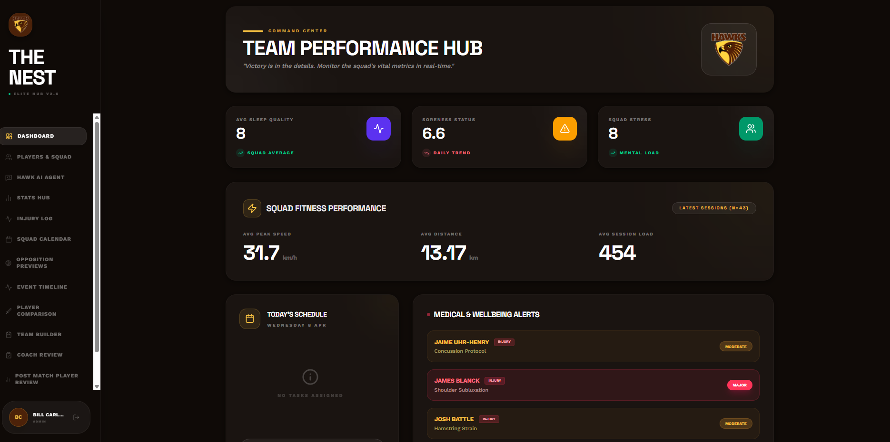
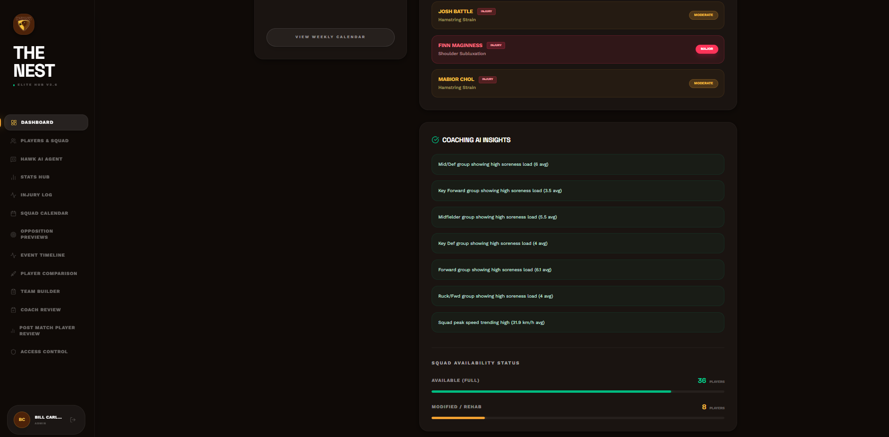

- Title: Player Profile
- Function: A personalized performance hub for the individual athlete to view their own metrics and professional development consisting of three screens; personal info, footy overview and fitness performance.
- Features: Personal info, performance information, wellbeing + medical, personal goals, season form, readiness score (based off sleep, soreness, mood)
- Future Consideration: AI insights, GPS visualisation
- Access: Players (Only their own profile), Coaches (all players)
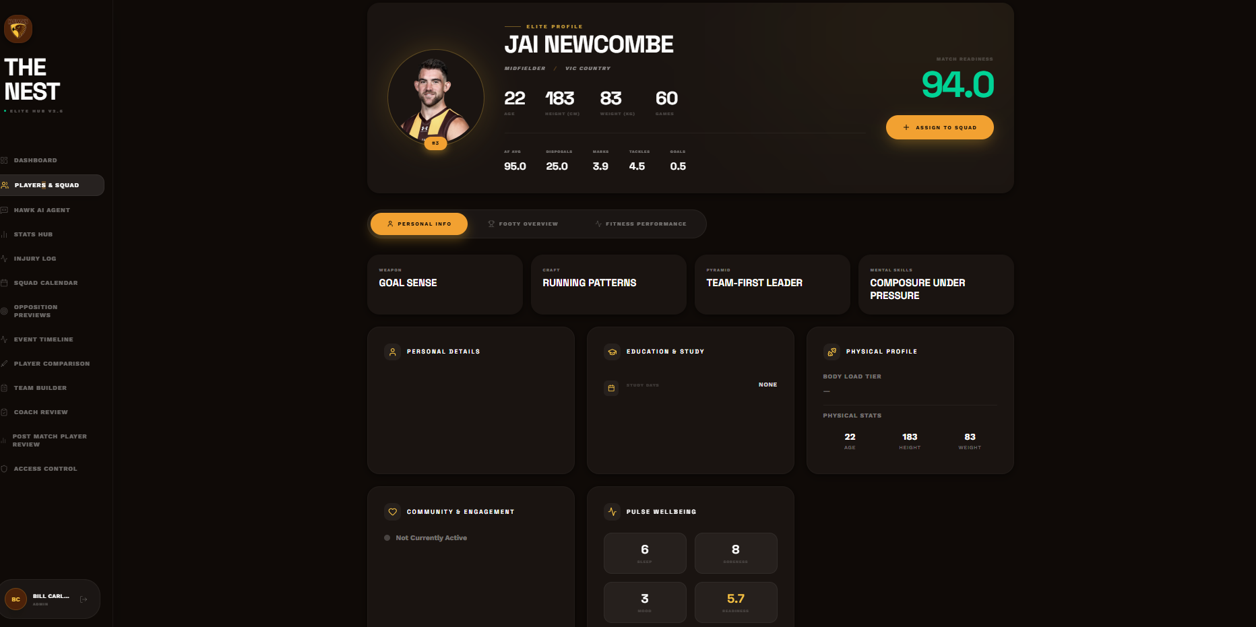
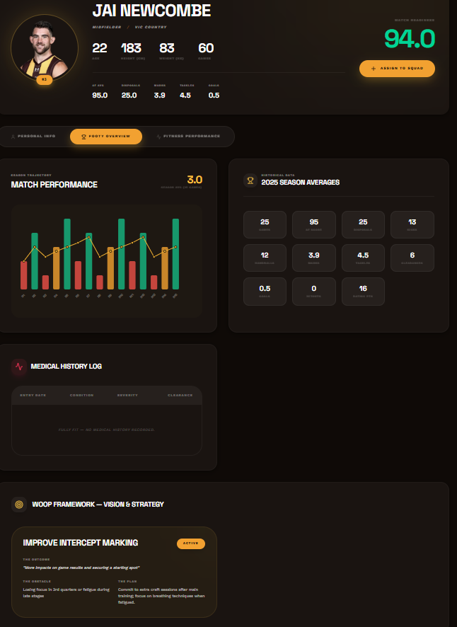
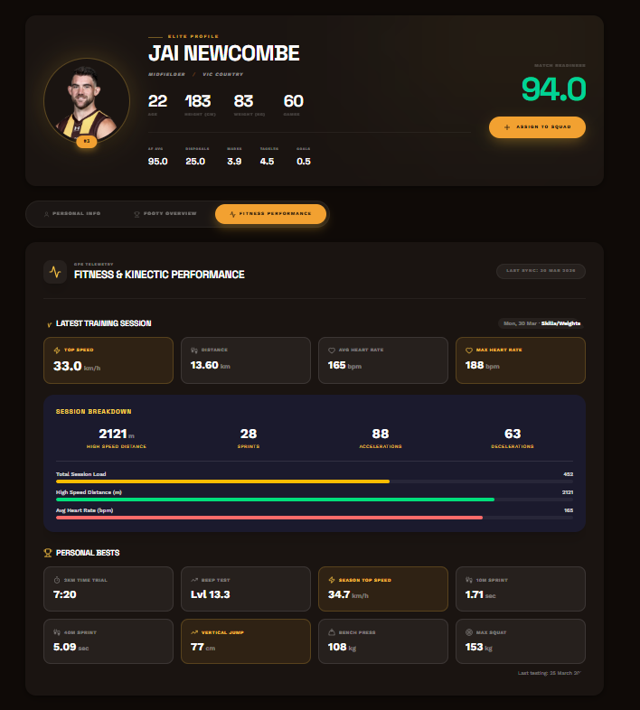
3. Squad & Athlete Management
- Title: Squad
- Function: Managing the active roster and providing a quick-access directory for staff.
- Features: Searchable player list, Jumper number indexing, Quick-glance role/position tags, and direct links to full profiles.
- Future Consideration: Integration of "Contract Status" and "List Management" markers for long-term squad planning.
- Access: Coaches
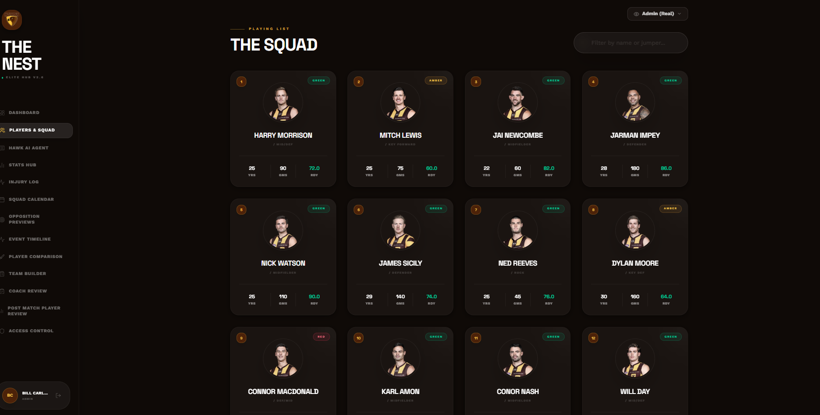

4. High Performance & Medical
- Title: Injury & Load Log (Medical Dashboard)
- Function: Tracking player availability, rehabilitation status, and physical workload.
- Features: Secured "Entry Form" for medical staff, KPI Matrix (Active/Recovering/Cleared counts), Body Area mapping, and Severity/Notes logging.
- Future Consideration:
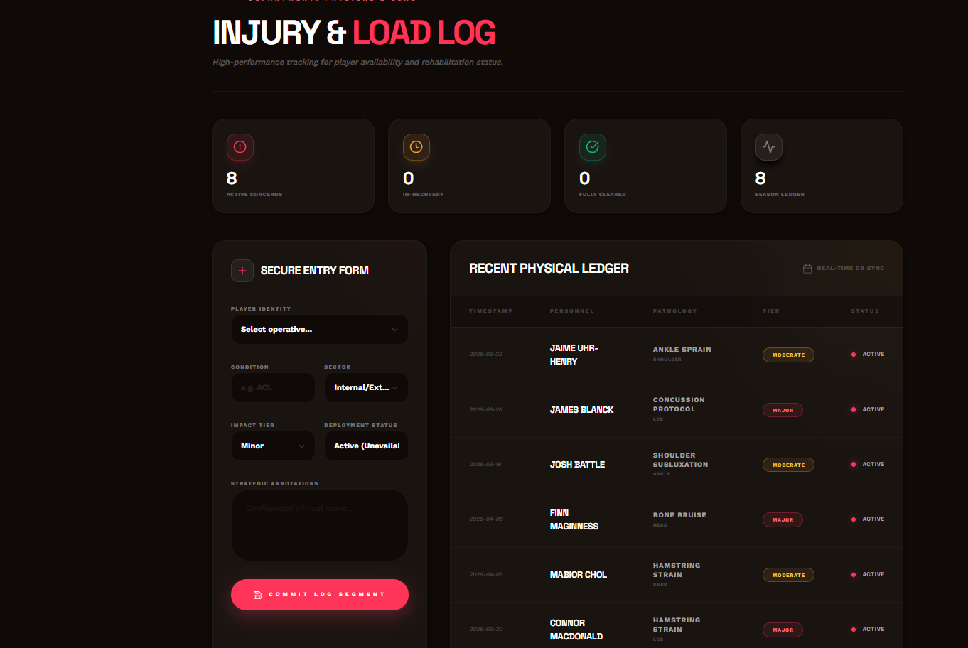

4-cont
- Title: Daily Check-In (Player Readiness)
- Function: Capturing morning subjective data from athletes to monitor wellness and potential overtraining.
- Features: Slider-based inputs for Sleep Quality, Mood, Stress, and Muscle Soreness; optional RPE (Rate of Perceived Exertion) logging for training sessions.
- Future Consideration: Notifications for medical staff when a player’s stress score deviates from their rolling 7-day average.
- Access: Players
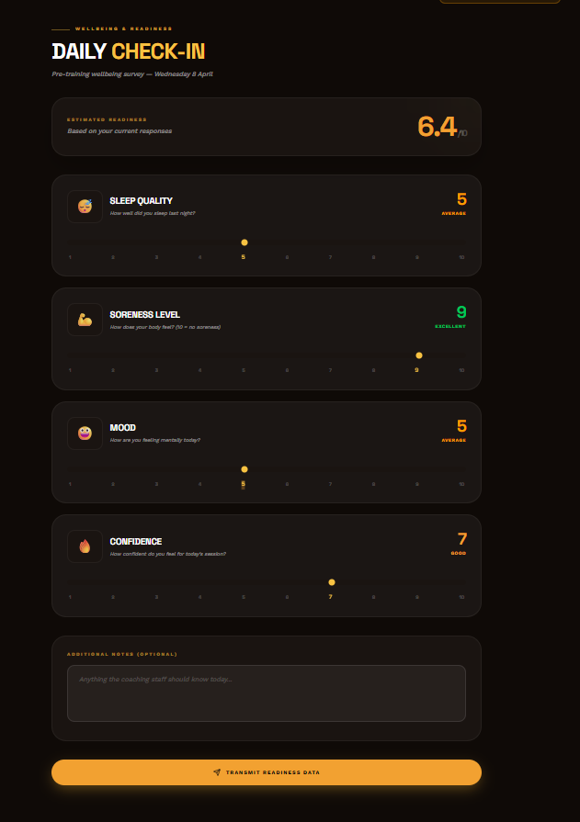

4-cont
- Title: Stats Hub
- Function: Quantitative performance analysis platform for comparing statistical output across the whole team.
- Features: Sortable Metric Table, "Average vs. Total" toggles, Heatmap cell color-coding (Elite/Neutral/Under), and refined CSV data export.
- Future Consideration: "Correlation Engine"—identifying which stats (e.g., Clearances vs. Marks) most accurately predict a winning AFL score for HFC.
- Access: Everyone
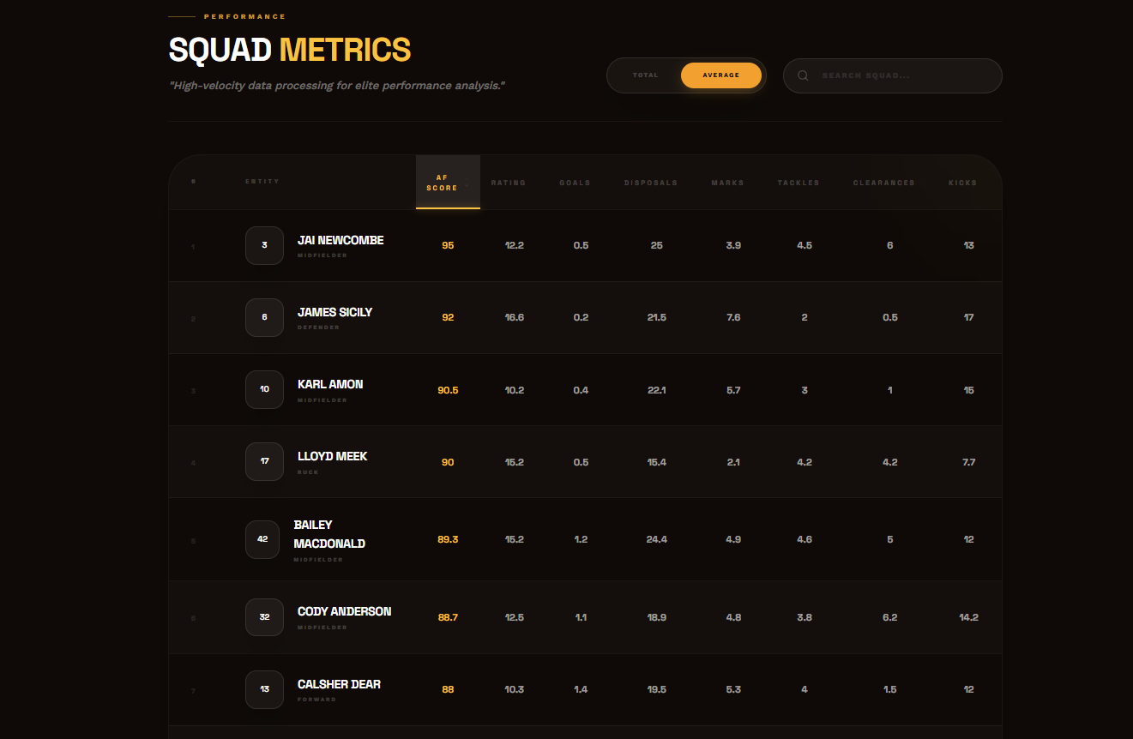

5. Tactical & Match Center
- Title: Team Builder
- Function: Digital "Magnet Board" for match-day scenario planning and team selection.
- Features: Drag-and-drop player magnets, Position-specific zones, Round-based versioning (e.g., "Taller Forward Line" vs. "Initial Selection"), and Tactical Notes.
- Future Consideration: AI insights into lineup
- Access: Coaches
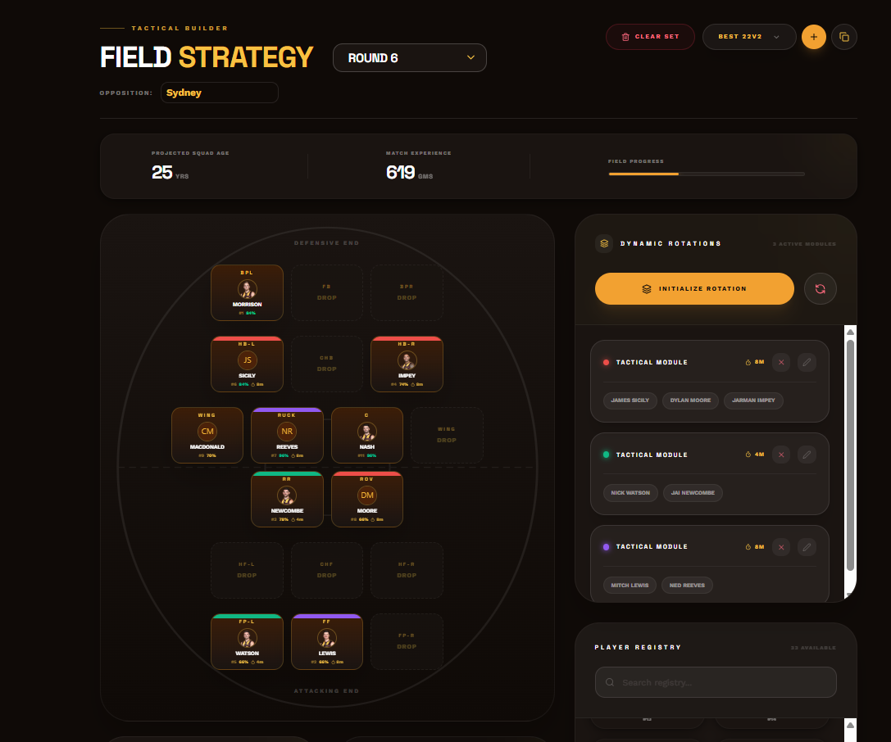
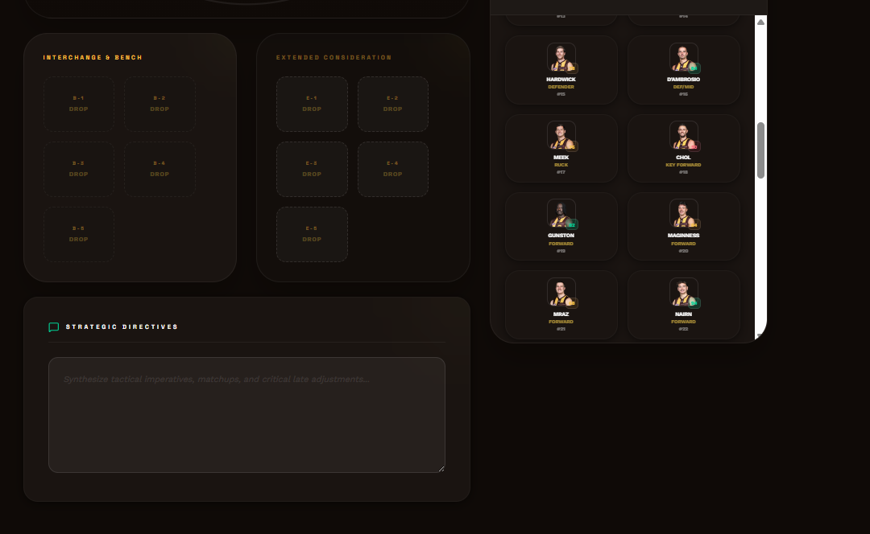

5-cont
- Title: Player Comparison
- Function: Direct head-to-head tactical profiling between two athletes (internal vs. internal or internal vs. external scout data).
- Features: Side-by-side bar charts for physical profile (Height/Weight), Match stats, and Coaching assessment ratings.
- Future Consideration: "Archetype Mapping"—AI identifying the closest stylistic match to an opposition star within our own squad for scout-simulated training.
- Access: Coaches
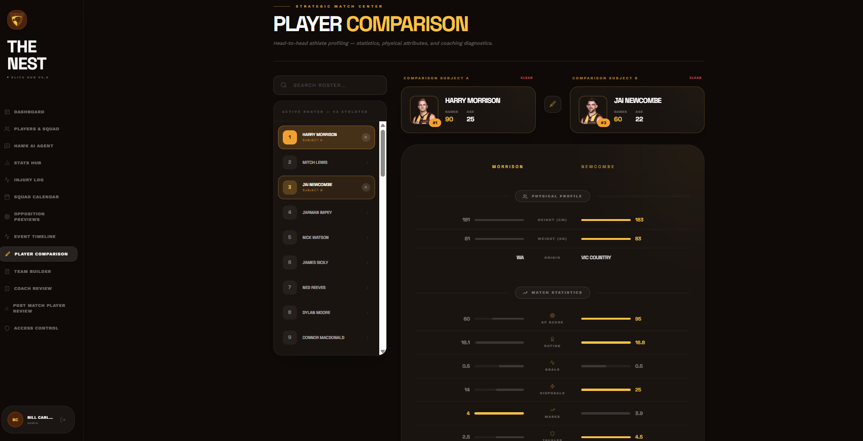

5-cont
- Title: Opposition Previews (Concept)
- Function: Centralizing analysis and strategy reports for upcoming opponents. Mainly utilizing champion data “Head Start” insights. Less of a chatbot, more like an “opposition guide”
- Features: Document/PDF links for scout reports, "Target Player" lists, and tactical "Watch-outs" with priority markers.
- Future considerations: Help with team selection, tactic, matchups
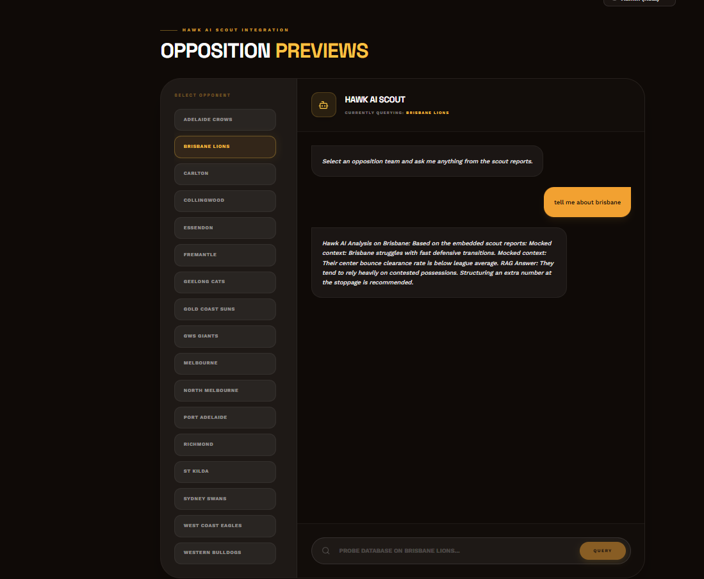

6. Performance Feedback & Ratings
- Title: Coaches Ratings
- Function: The intake point for coaches to submit technical and tactical player assessments post-match.
- Features: Slider-based grading (1-10) for specific skills (Kicking, Decision Making, etc.), "Category" grouping, and "Bulk Save" functionality.
- Future Consideration:
- Access: Coaches
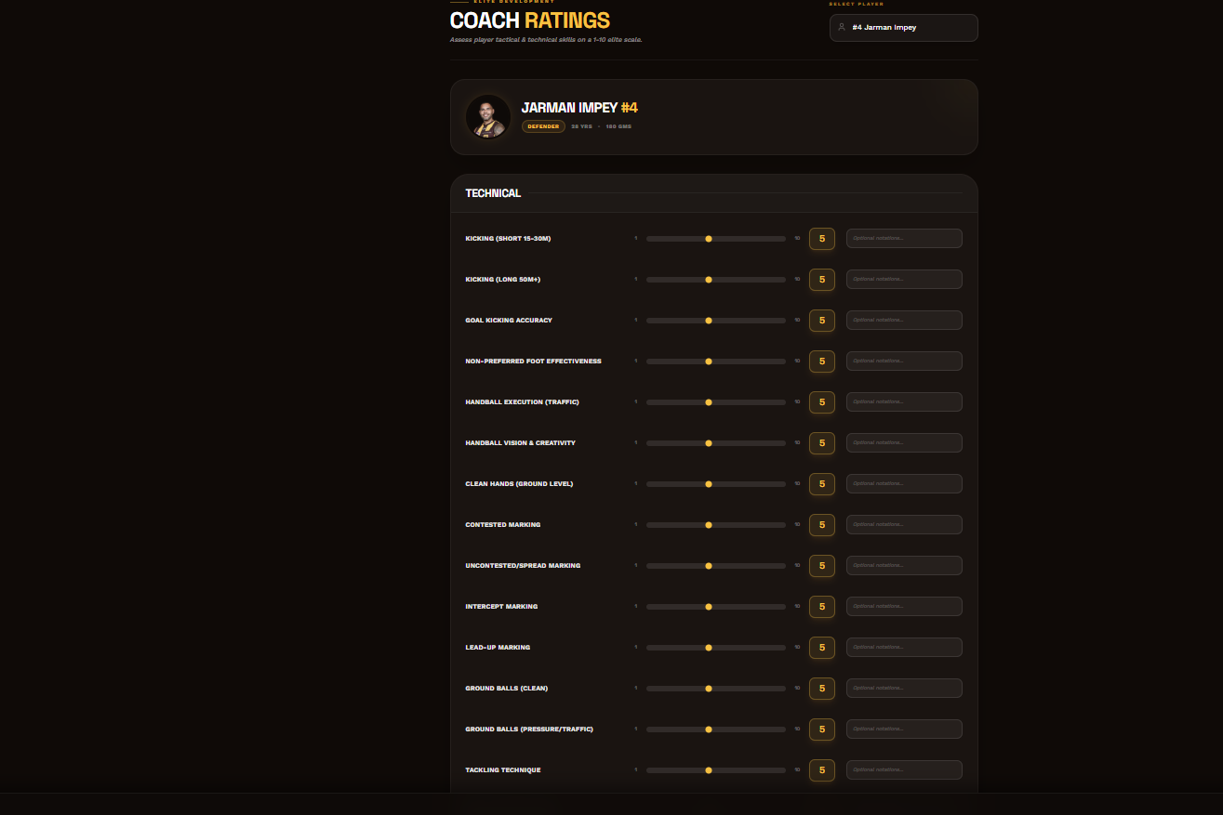

6-cont
- Title: Ratings Comparison (Diagnostic Hub)
- Function: Visualizing "The Perception Gap"—the difference between how a coach rated a player and how that player rated themselves.
- Features: Radar Charts (Coach vs. Self vs. Squad Avg), Alignment Deviation metrics, and longitudinal "Evolution" heatmaps.
- Future Consideration: Flagging entries where a player’s self-rating is >2 points higher than the coach's, signalling a need for a feedback meeting.
- Access: Coaches only
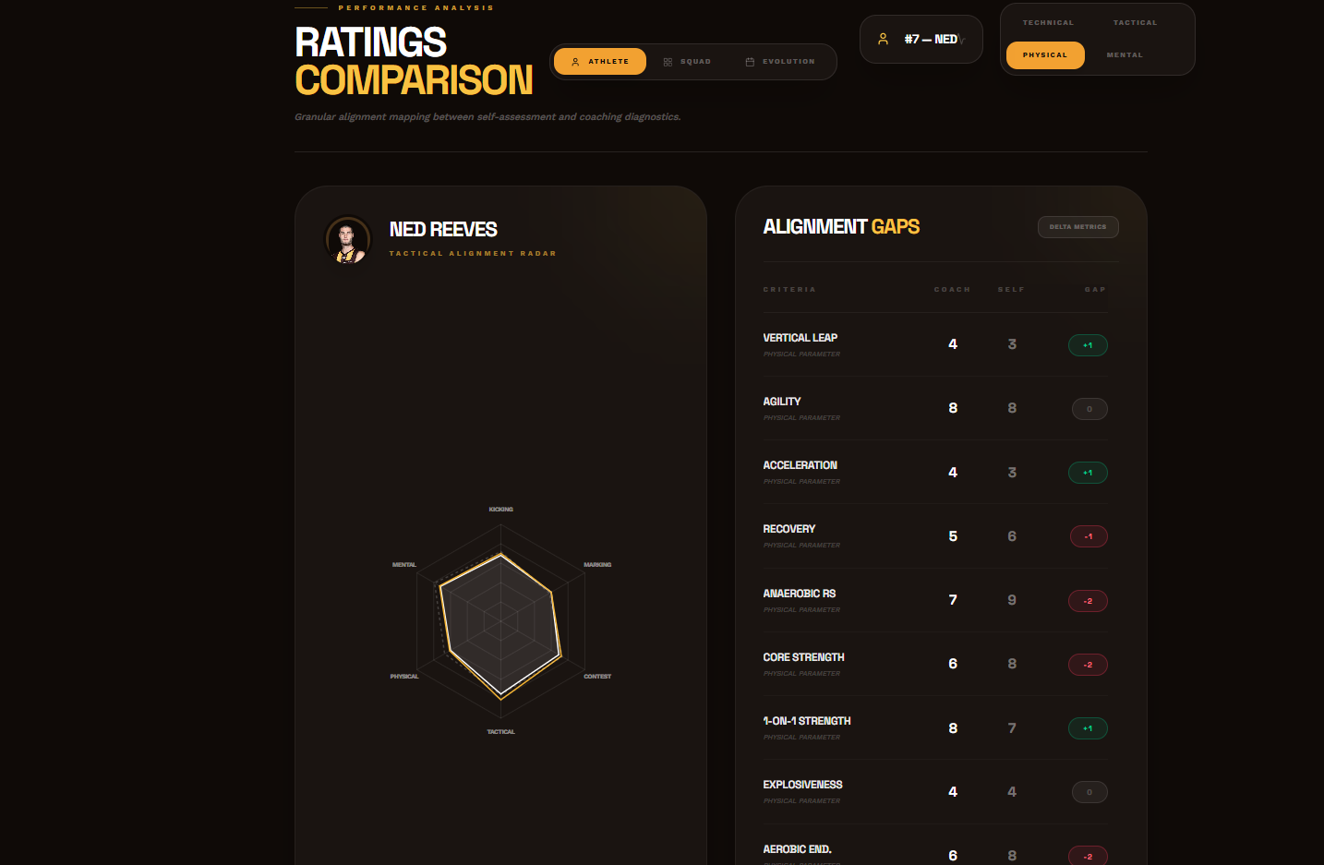
Shows coaches ratings vs players self-ratings

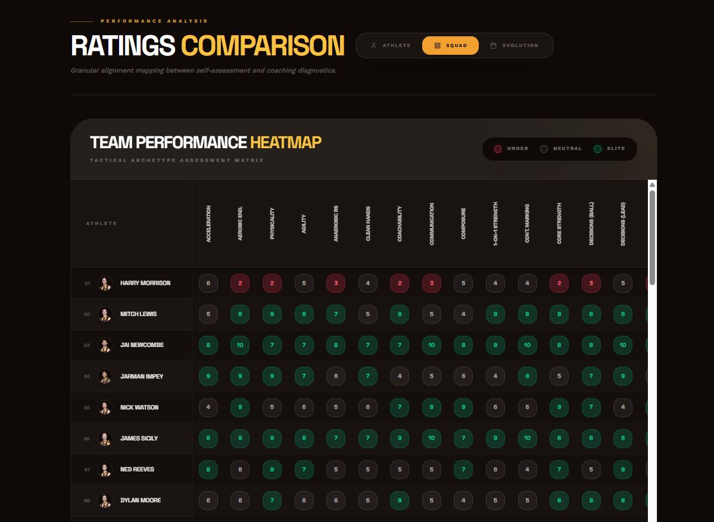
Shows how the entire team rated in the selected round

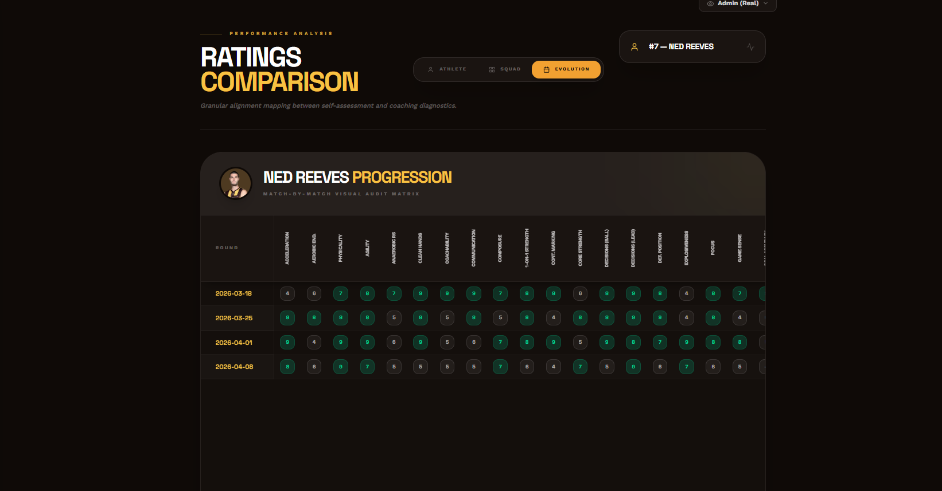
Shows how the selected player has rated over the season

6-cont
- Title: Post-Match Player Review (Self-Assessment)
- Function: Secure portal for players to reflect on their own match-day performance.
- Features: Private rating submission matching the coach’s criteria, free-text "Reflections”.
- Future Consideration: Integration of "WOOP" goal outcomes directly into the match review form.
- Access: players
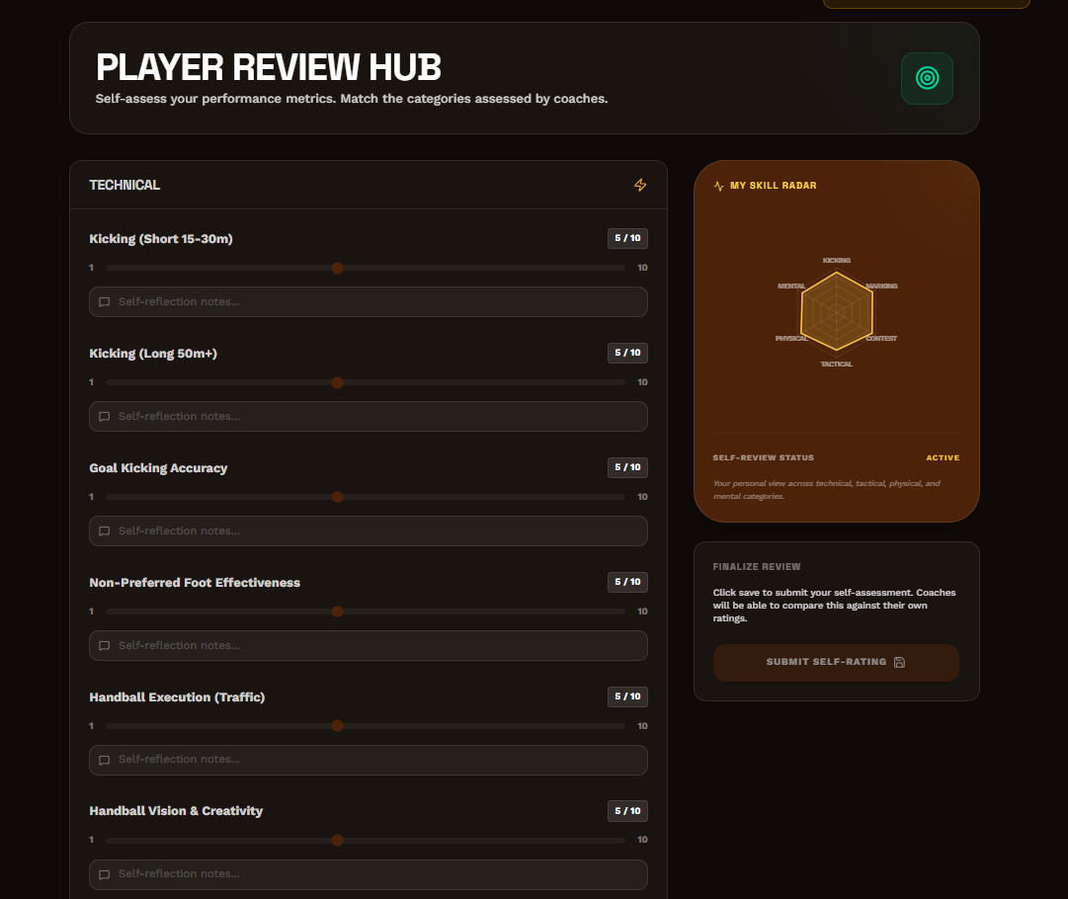

7. Goal setting and development
- Title: WOOP Goals (Psychological Performance)
- Function: Implementation of the "Wish, Outcome, Obstacle, Plan" framework for psychological development.
- Features: Goal creation workflow with dedicated sections for overcoming obstacles; historical goal tracking.
- Future Consideration: Provide data backed insights into how goal is progressing
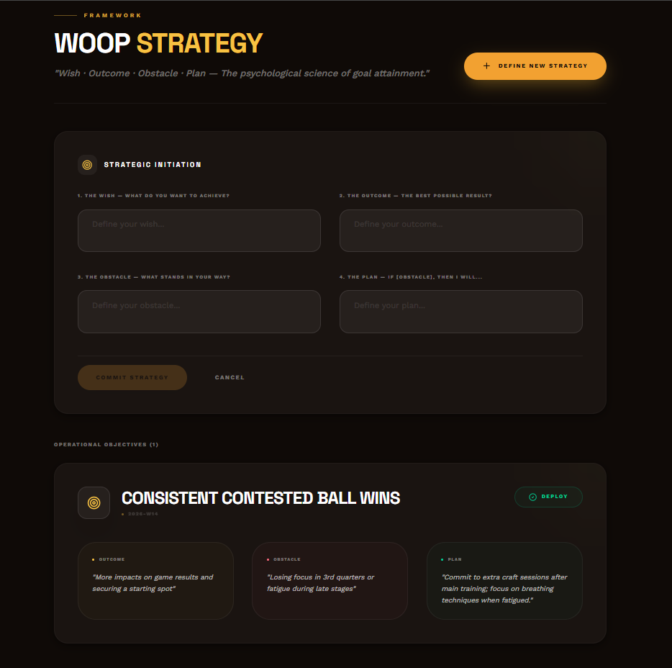

8. AI chatbot
- Title: Hawk AI Agent
- Function: An LLM-powered assistant for data interrogation and tactical querying.
- Features: Chat-based interface with access to "Squad Context," ability to answer questions like "Who are the top 3 best kickers in the squad based on ratings?", and narrative performance summaries.
- Future Consideration: "Auto-Report Generation"—generating a full weekly training summary in narrative form for the Head Coach.
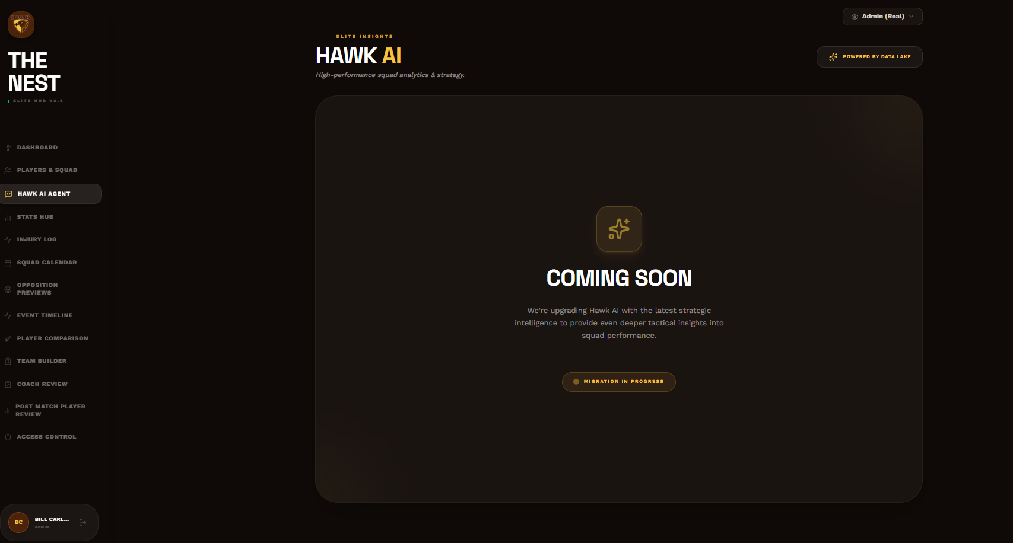

8. System Administration
- Title: Admin Settings & User Management
- Function: Centralized control for user permissions, role assignments, and authorized emails.
- Features: Email whitelist management, Role toggles (Coach/Player/Admin), Jumper number assignments for players, and master database seeding controls.
- Future Consideration: Control via Google groups
